Identification of Anthocyanin, Flavonoids, Triterpenoids and Phosphatidylcholines from Rhododendron arboreum by Using LC ESI MS /MS Analysis

Figure S39 M.W. 354 at 0.88 m RT (Bu)
Figure S40 M.W. 448 at 1.15 m RT (ETH)
Figure S41 M.W. 599 at 1.2 m RT (DCM)
Figure S42 M.W. 408 at 1.26 m RT (ETH)
Figure S43 M.W. 302 at 1.42 m RT (ETH)
Figure S44 M.W. 502 at 9.3 m RT (Bu)
Figure S45 M.W. 488 at 10.92 m RT (Bu)
Figure S46 M.W. 502 at 11.42 m RT (Bu)
Figure S47 M.W. 314 at 11.9 m RT (DCM)
Figure S48 M.W. 516 at 12.13 m RT (ETH)
Figure S49 M.W 698 at 12.73 m RT (Bu)
Figure S50 M.W 812 at 13.17 m RT (Bu)
Figure S51 M.W 543 at 13.8 m RT (DCM)
Figure S52 M.W. 724 at 13.95 m RT (Bu)
Figure S53 M.W 752 at 14.26 m RT (ETH)
Figure S54 M.W. 596 at 14.46 m RT (Bu)
Figure S55 M.W. 477 at 14.77 m RT (Bu)
Figure S56 M.W. 557 at 15.30 m RT (DCM)
Figure S57 M.W. 563 at 15.77 m RT (Bu)
Figure S58 M.W. 530 at 16.03 m RT (ETH)
Figure S59 M.W. 408 at 16.1 m RT (DCM)
Figure S60 M.W. 558 at 16.4 m RT (DCM)
Figure S61 M.W. 565 at 17.2 m RT (BU)
Figure S62 M.W. 633 at 17.92 m RT (Bu)
Figure S63 M.W. 1126 at 18.2 m RT (DCM)
Figure S64 M.W 708 at 19.05 m RT (ETH)
Figure S65 M.W. 1126 at 19.3 m RT (DCM)
Figure S66 M.W. 328 at 19.89 m RT (Bu)
Figure S67. Stack chromatograms of ethyl acetate, dichloromethane and butanol extracts of R. arboreum in ESI ^{–ve} mode

Table S1. Chromatographic and mass spectrometric data of R. arboreum in ESI^{-ve} mode

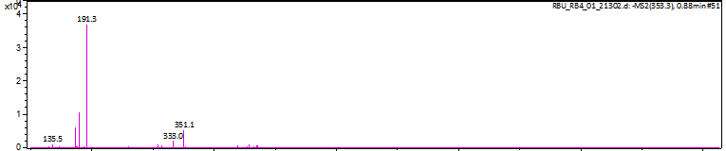
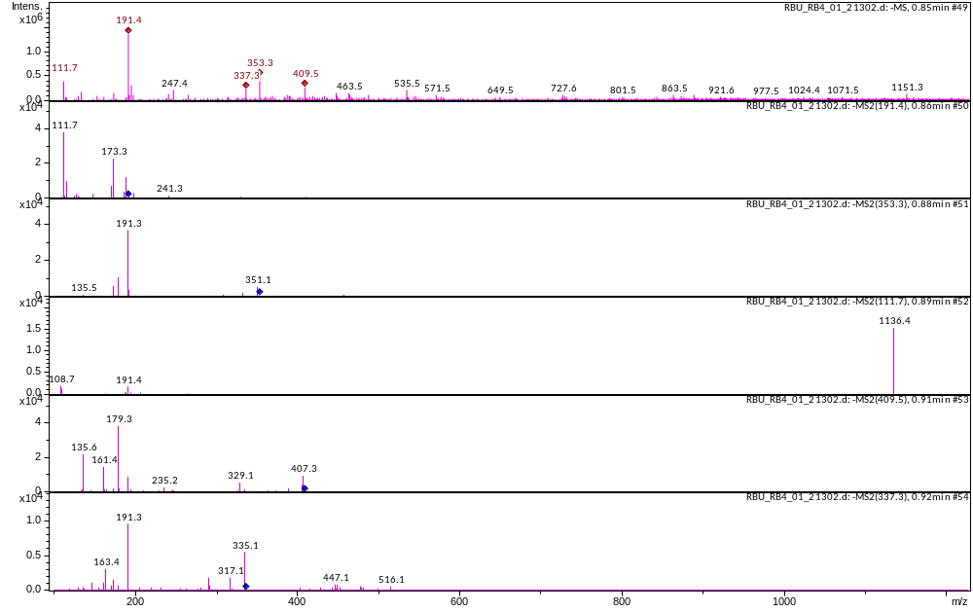
Figure S39 M.W. 354 at 0.88 m RT (Bu)

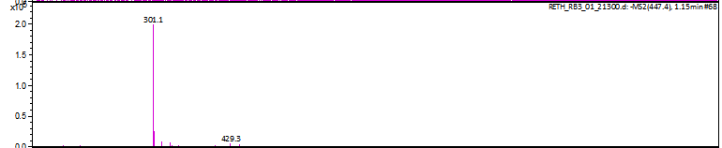
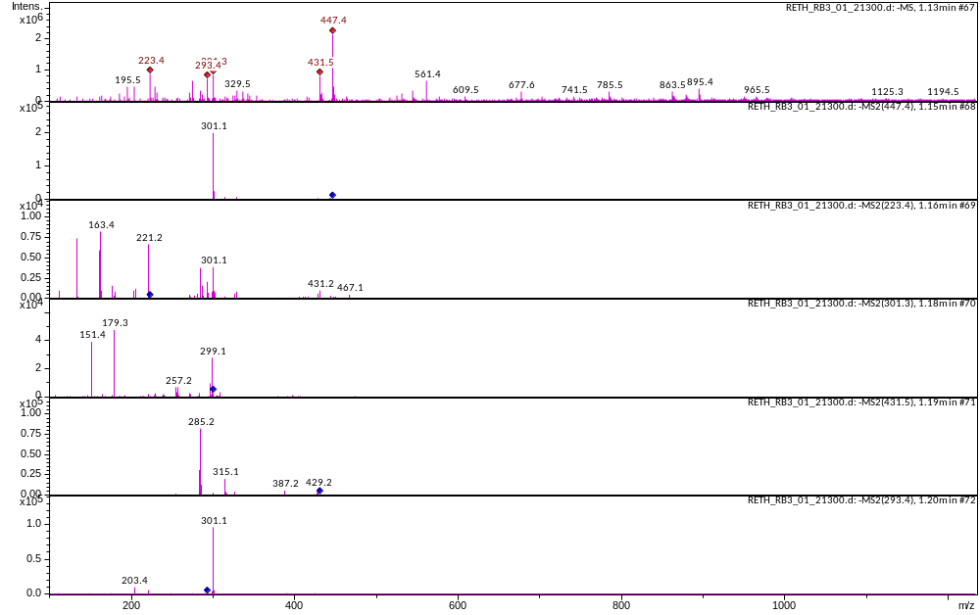
Figure S40 M.W. 448 at 1.15 m RT (ETH)

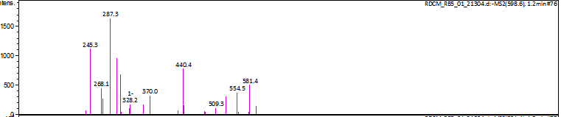
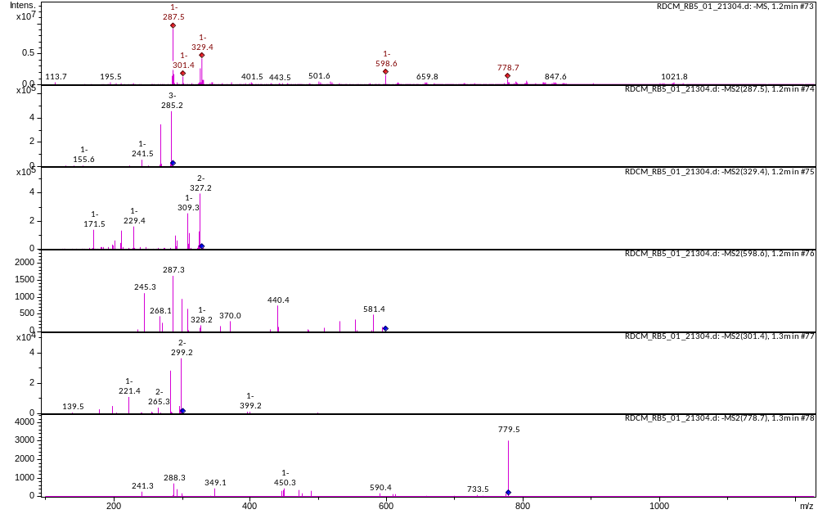
Figure S41 M.W. 599 at 1.2 m RT (DCM)

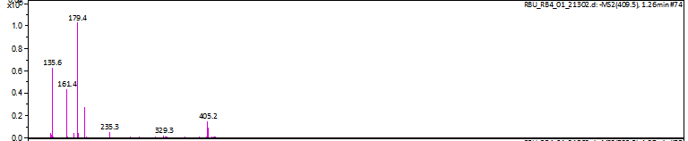
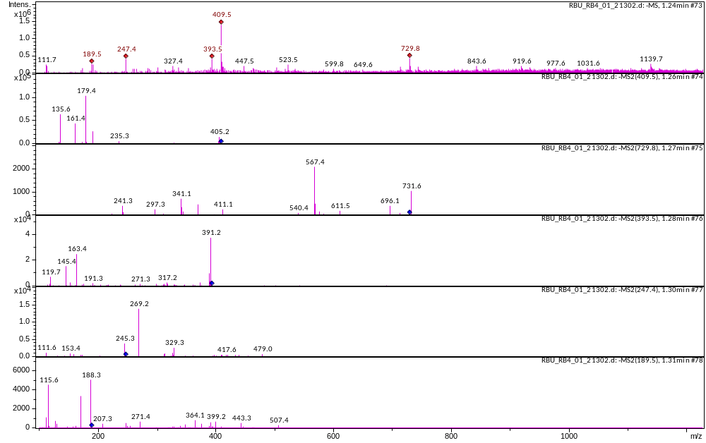
Figure S42 M.W. 408 at 1.26 m RT (BU)

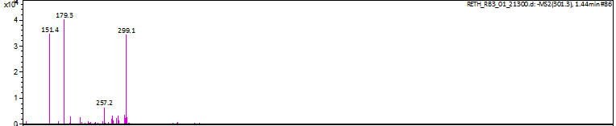
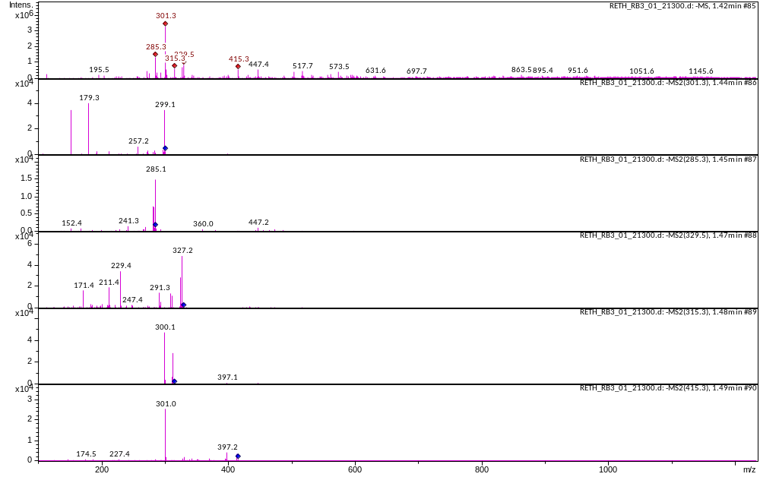
Figure S43 M.W. 302 at 1.42 m RT (ETH)

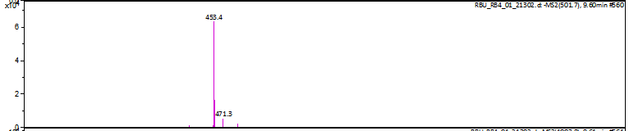
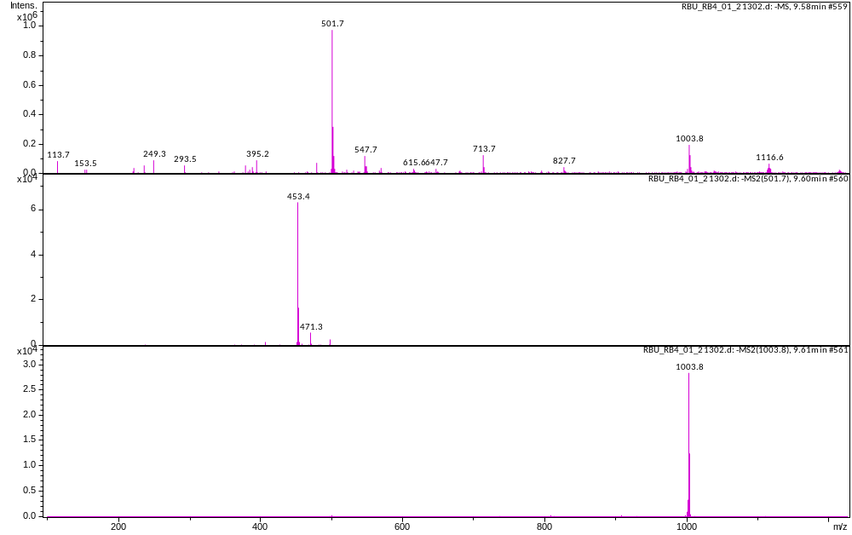
Figure S44 M.W. 502 at 9.3 m RT (Bu)

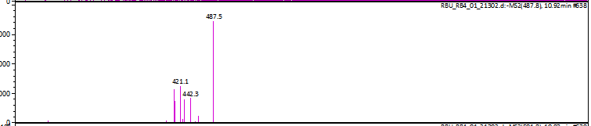
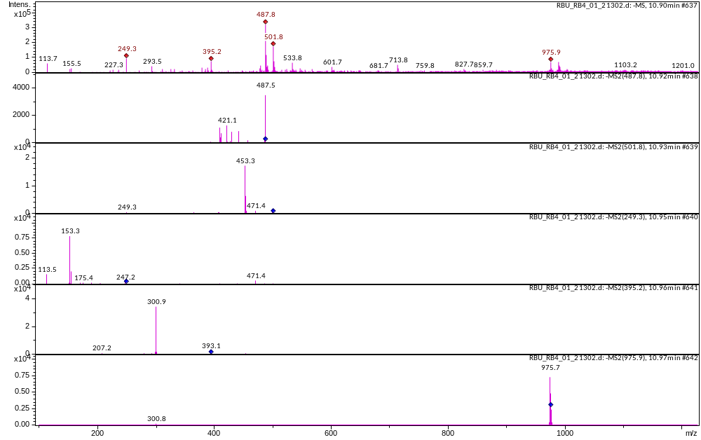
Figure S45 M.W. 488 at 10.92 m RT (Bu)

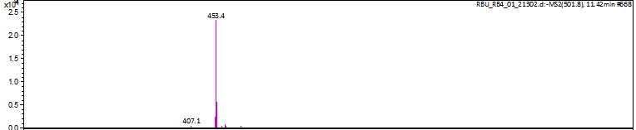
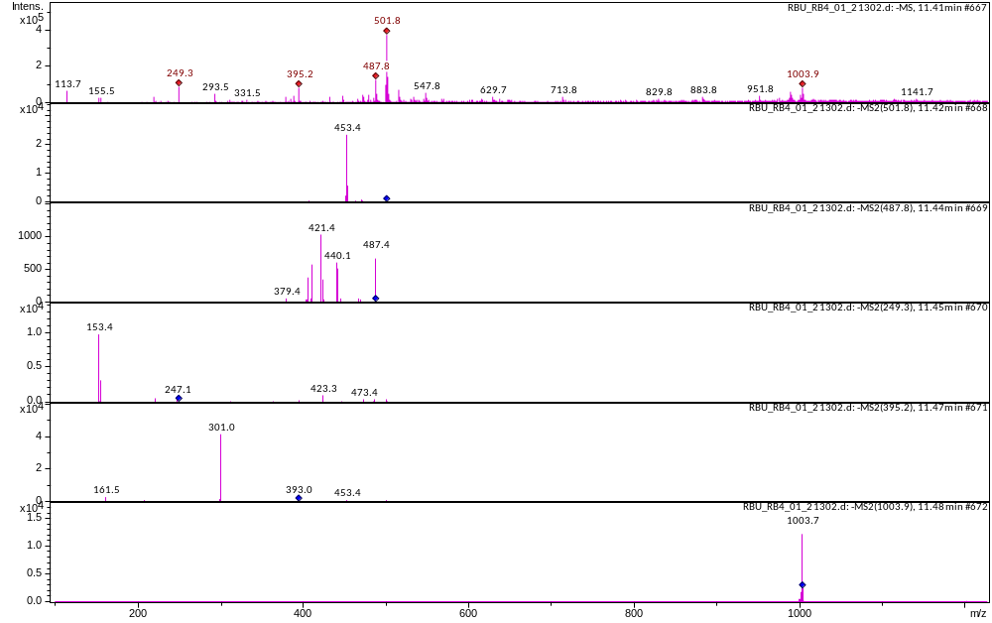
Figure S46 M.W. 502 at 11.42 m RT (Bu)

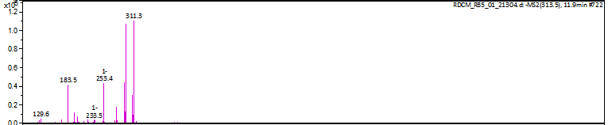
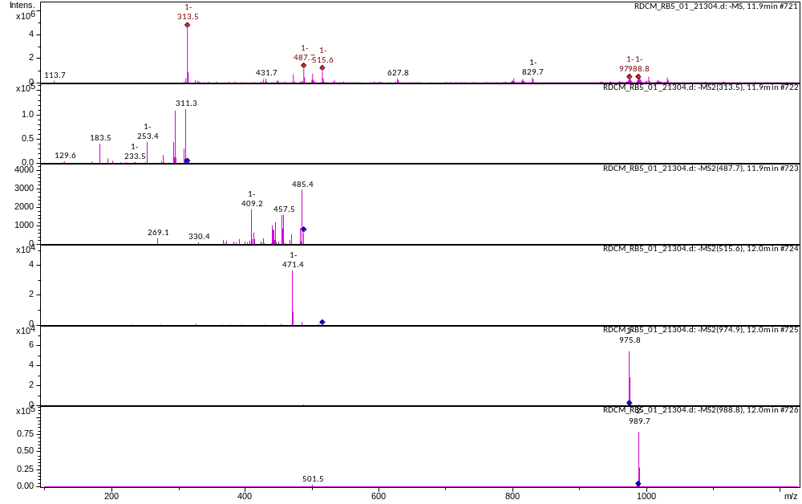
Figure S47 M.W. 314 at 11.9 m RT (DCM)

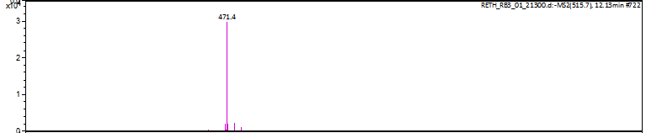
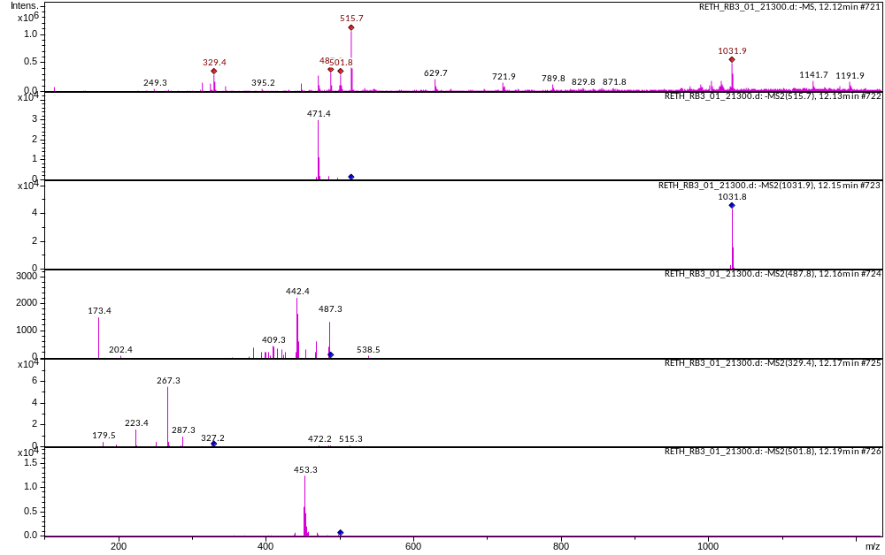
Figure S48 M.W. 516 at 12.13 m RT (ETH)

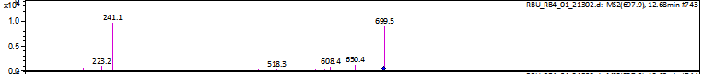
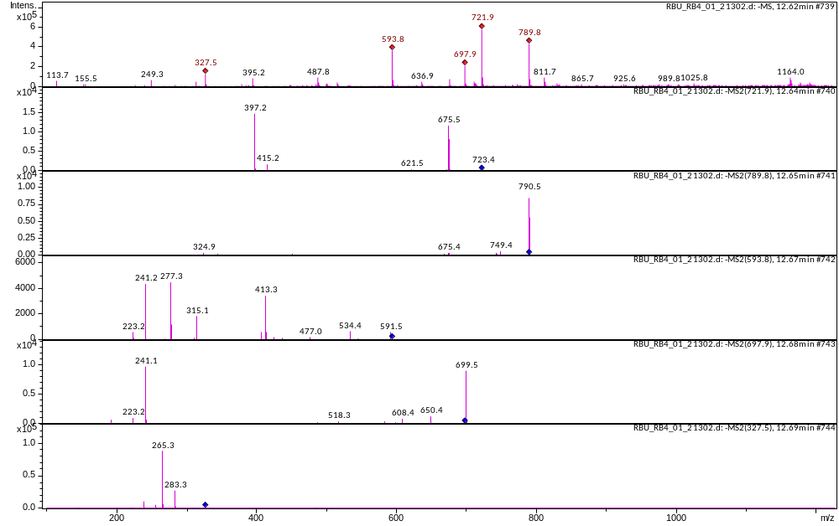
Figure S49 M.W 698 at 12.73 m RT (Bu)

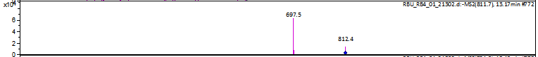
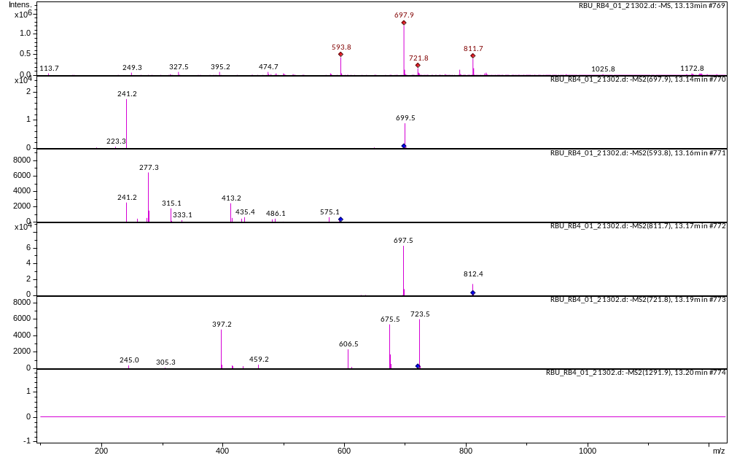
Figure S50 M.W 812 at 13.17 m RT (Bu)

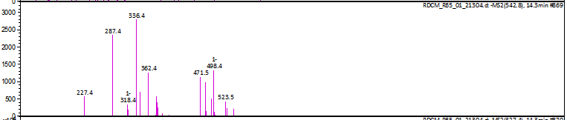
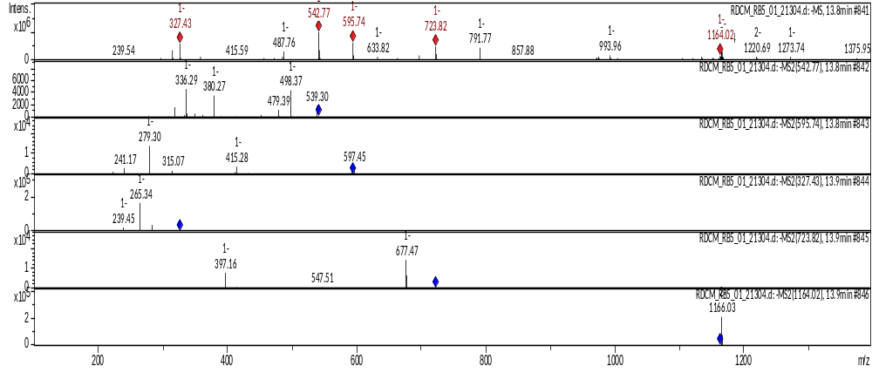
Figure S51 M.W 543 at 13.8 m RT (DCM)

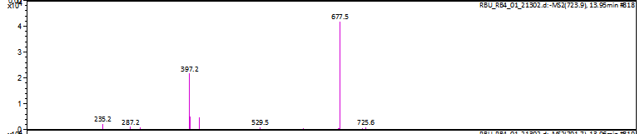
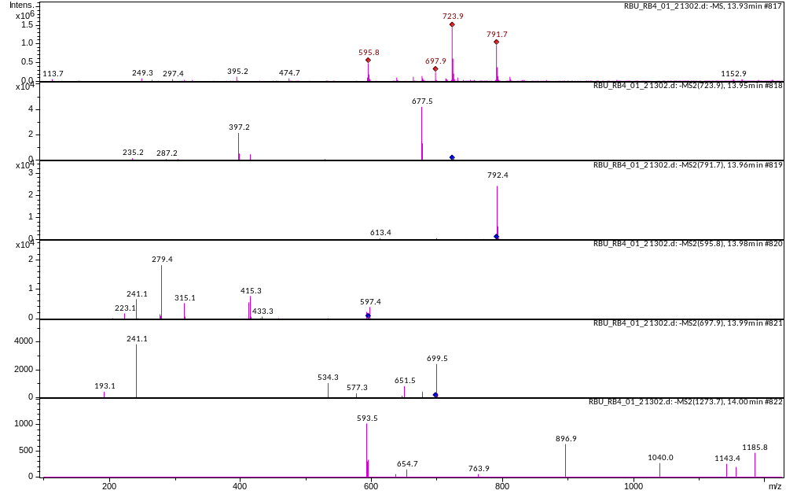
Figure S52 M.W. 724 at 13.95 m RT (Bu)

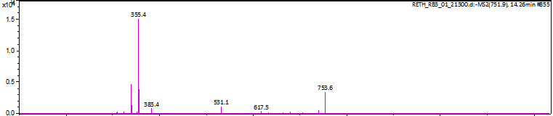
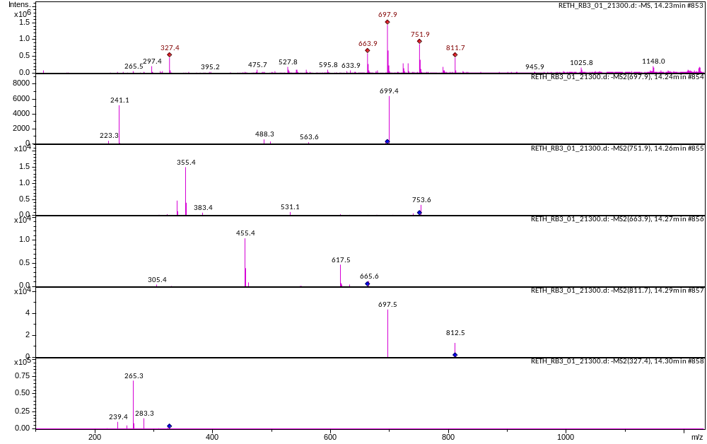
Figure S53 M.W 752 at 14.26 m RT (ETH)

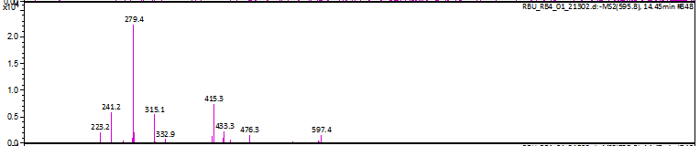
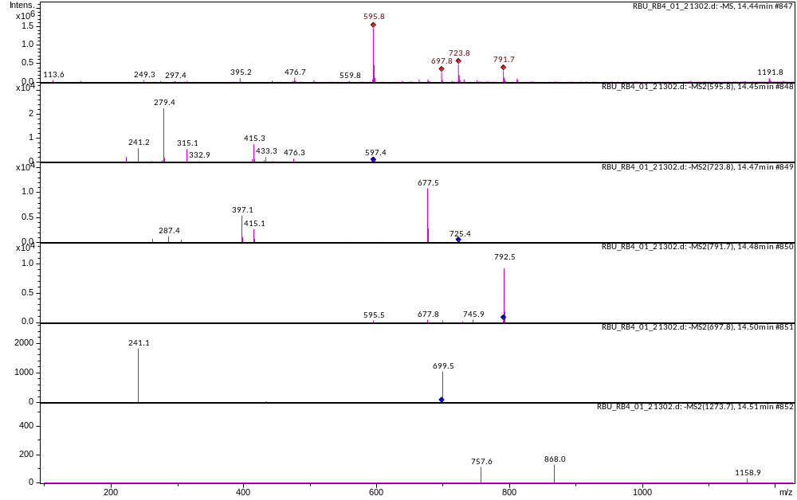
Figure S54 M.W. 596 at 14.46 m RT (Bu)

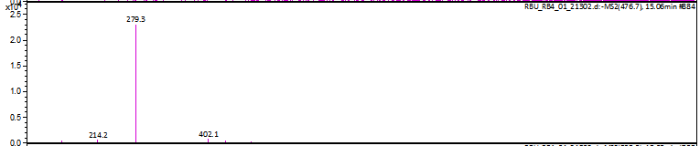
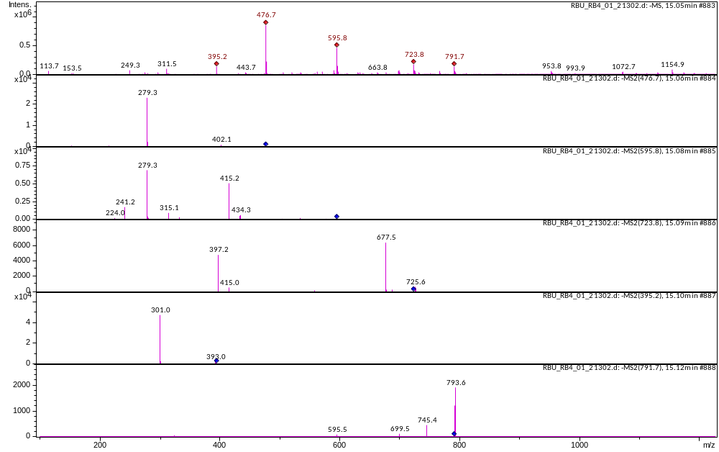
Figure S55 M.W. 477 at 14.77 m RT (Bu)

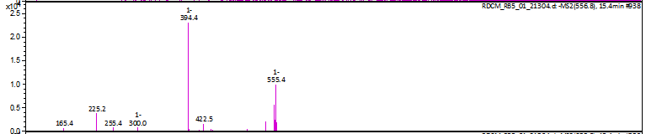
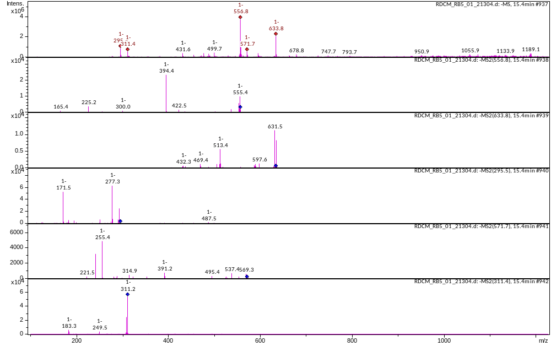
Figure S56 M.W. 557 at 15.30 m RT (DCM)

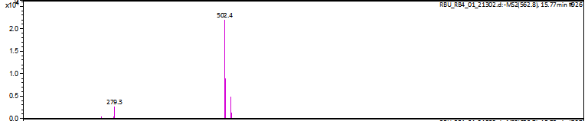
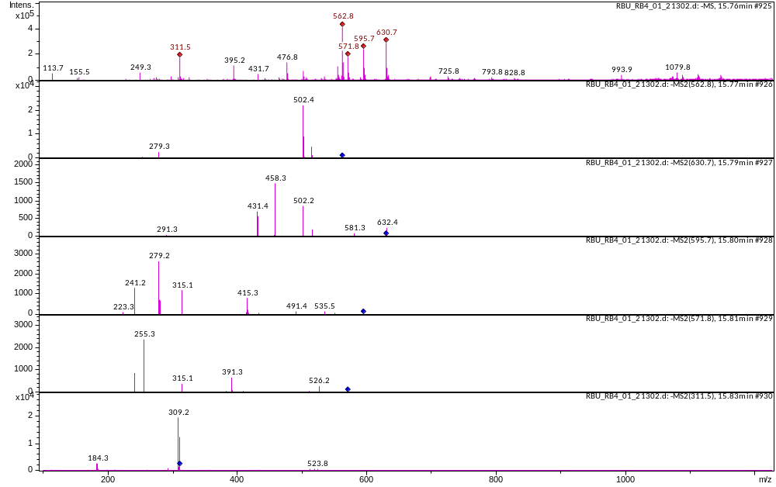
Figure S57 M.W. 563 at 15.77 m RT (Bu)

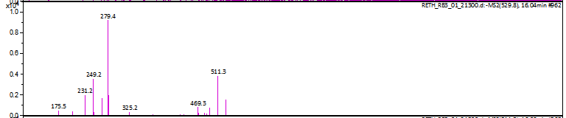
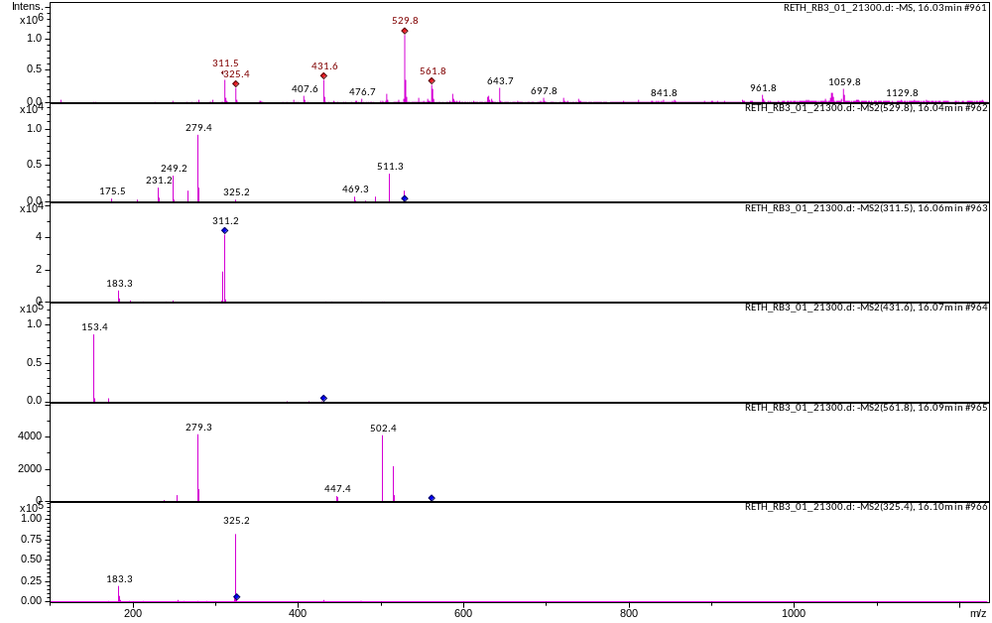
Figure S58 M.W. 530 at 16.03 m RT (ETH)

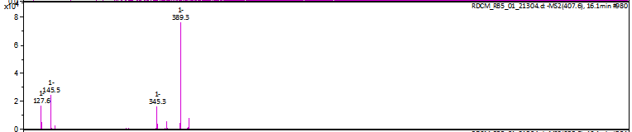
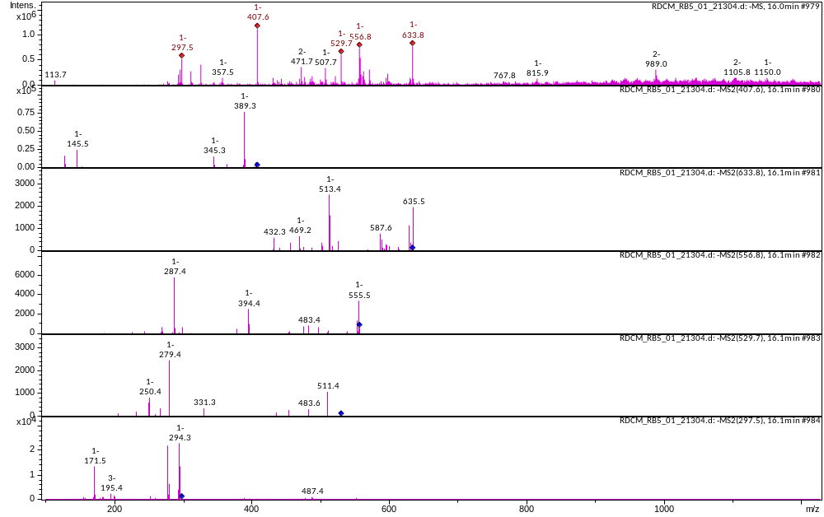
Figure S59 M.W. 408 at 16.1 m RT (DCM)

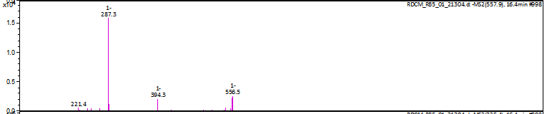
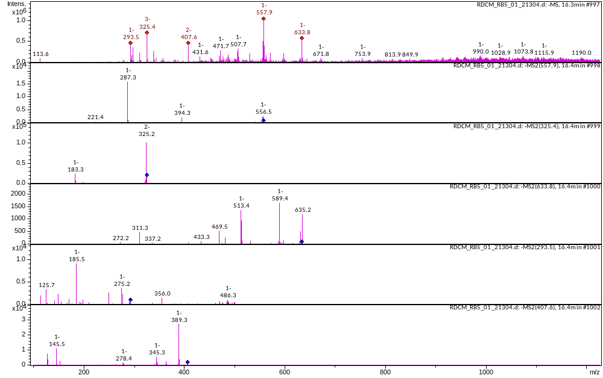
Figure S60 M.W. 558 at 16.4 m RT (DCM)

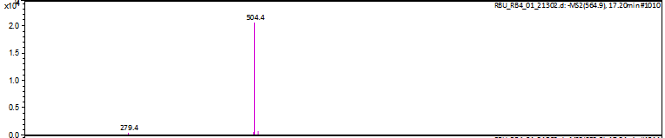
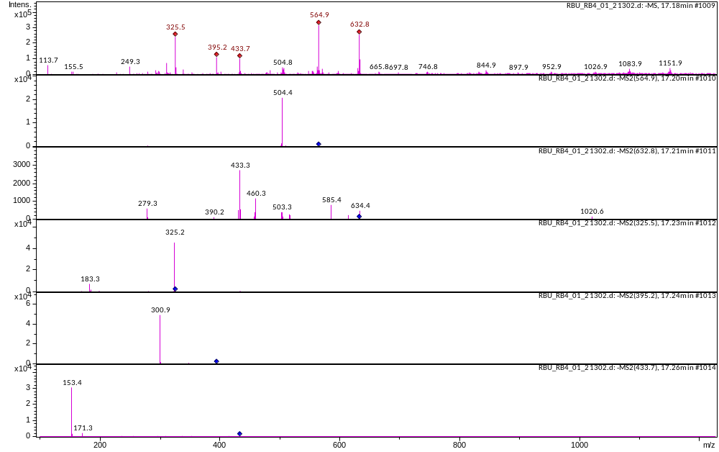
Figure S61 M.W. 565 at 17.2 m RT (BU)

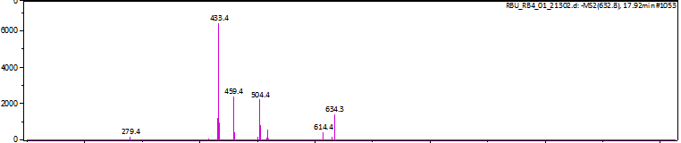
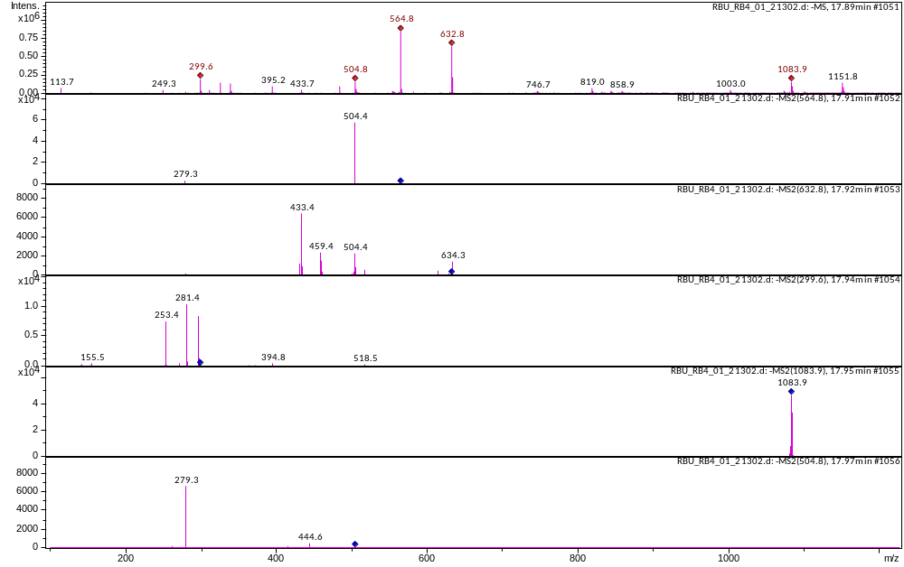
Figure S62 M.W. 633 at 17.92 m RT (Bu)

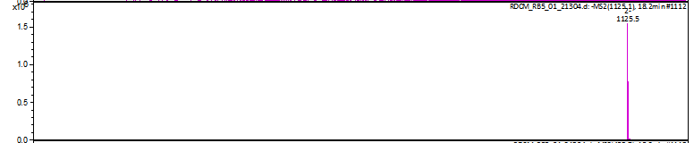
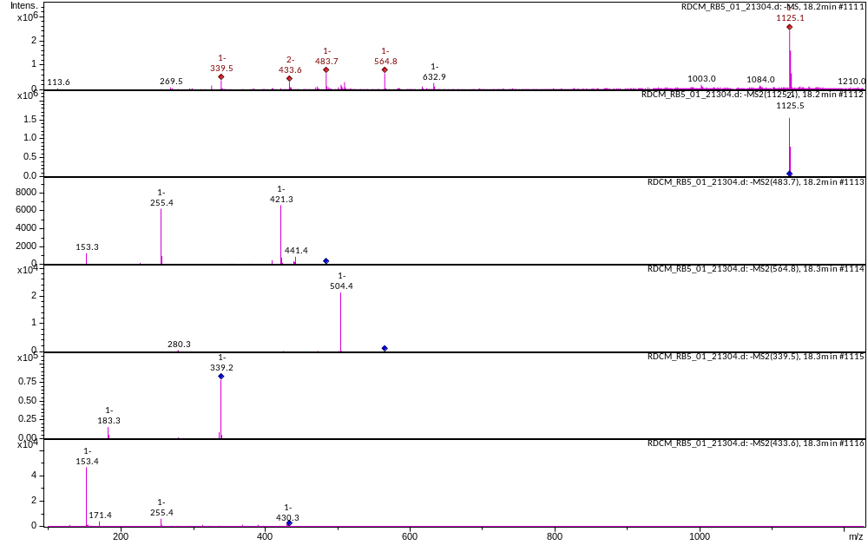
Figure S63 M.W. 1126 at 18.2 m RT (DCM)

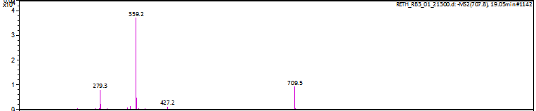
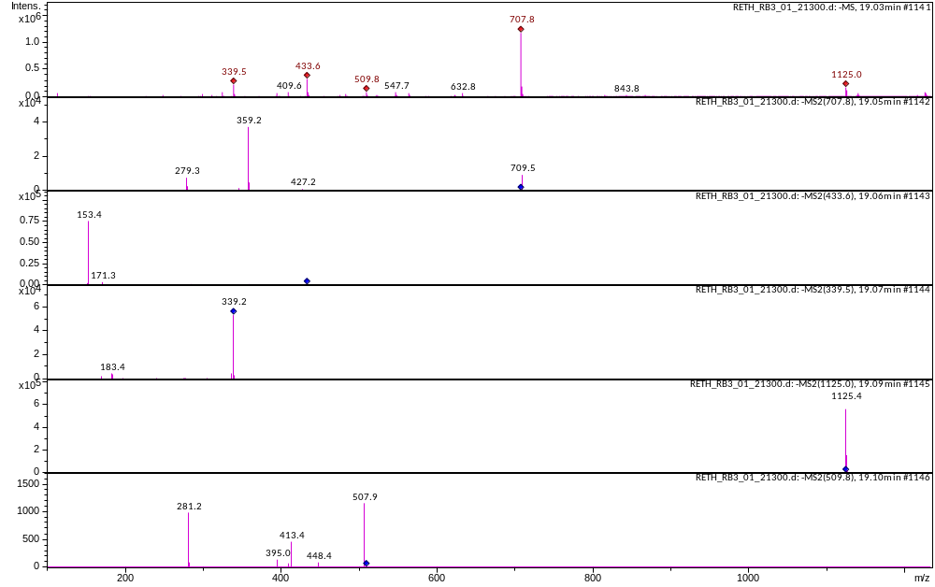
Figure S64 M.W 708 at 19.05 m RT (ETH)

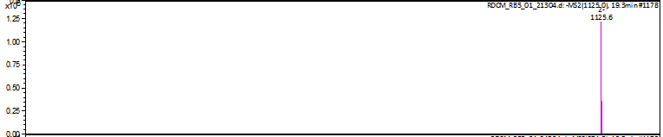
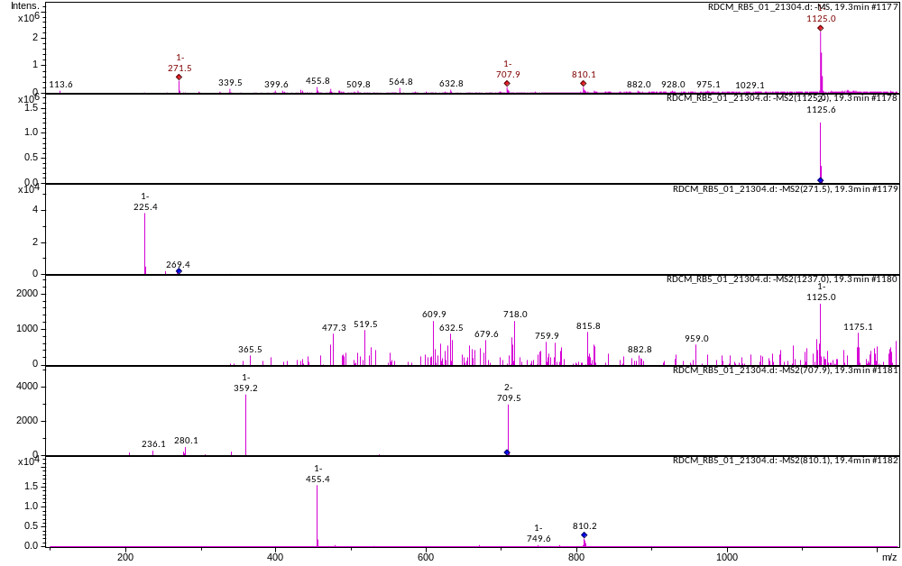
Figure S65 M.W. 1126 at 19.3 m RT (DCM)

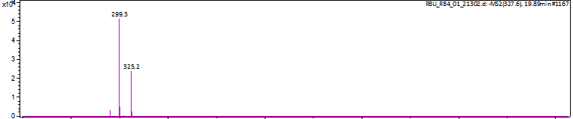
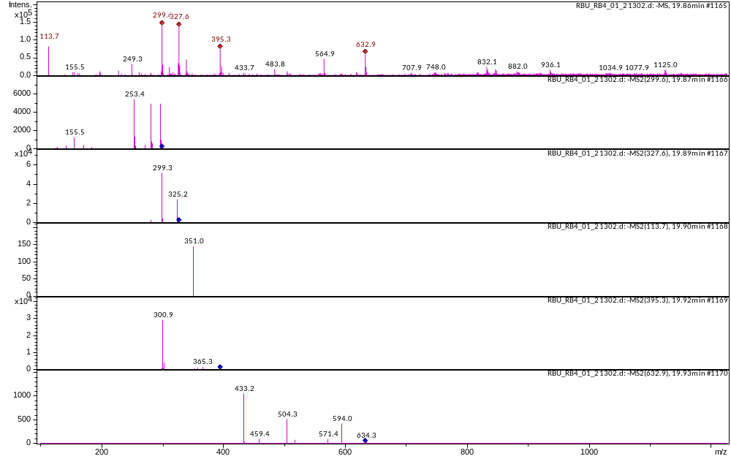
Figure S66 M.W. 328 at 19.89 m RT (Bu)

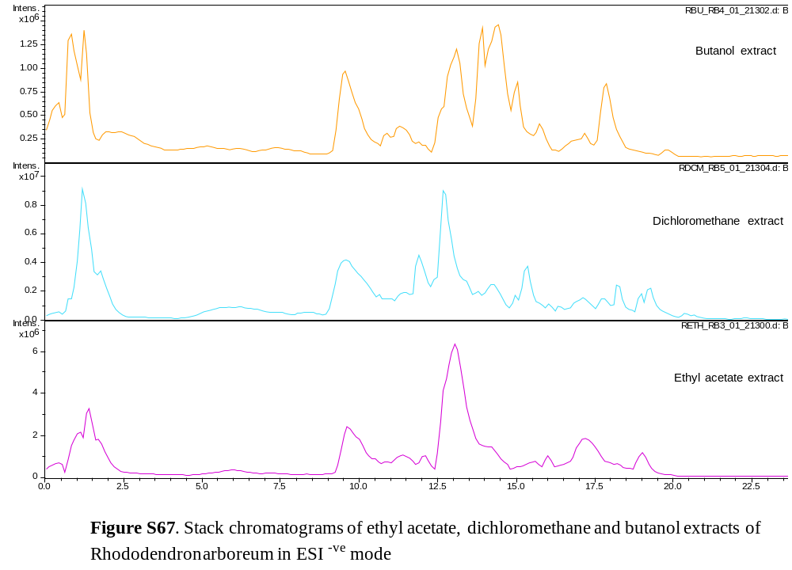

Table S1. Chromatographic and mass spectrometric data of R. arboreum in ESI^{-ve} mode

Ret time | Molwt | Measured mol wt | Product ions and intensity | ETH | Bu | DCM
0.88 | 354 | 353 | 191 (100), 173 (17) |  | +
1.15 | 448 | 447 | 301(100), 429 (5) | +
1.2 | 598 | 598 | 440 (40), 287(100), 245 (70) |  |  | +
1.26 | 410 | 409 | 179(100), 135 (60) |  | +
1.42 | 302 | 301 | 179(100),151 (80) | +
9.3 | 502 | 501 | 453 (100) | + | + | +
10.92 | 488 | 487 | 487 (100), 421(35) |  | +
11.42 | 502 | 501 | 453(100), 407(5) | + | + | +
11.9 | 314 | 313 | 311 (100), 253 (40), 183(40) |  |  | +
12.13 | 516 | 515 | 471(100) | +
12.73 | 698 | 697 | 699 (100), 241(90), | + | + | +
13.17 | 812 | 811 | 697(100), 812(25) |  | +
13.8 | 543 | 542 | 336(100), 380 (65), 498 (95) |  |  | +
13.95 | 724 | 723 | 677 (100),397 (60) |  | +
14.26 | 752 | 751 | 753 (25), 355(100) | +
14.45 | 596 | 595 | 415(35), 279(100) |  | + | +
14.77 | 477 | 476 | 402 (4), 279 (100) |  | + | +
15.30 | 557 | 556 | 394(100), 225 (20) |  |  | +
15.77 | 563 | 562 | 502(100), 279 (15) |  | +
16.03 | 530 | 529 | 279 (100), 511 (50) | +
16.1 | 408 | 407 | 389 (100), 345 (25), 145 (30) |  |  | +
16.4 | 558 | 557 | 287 (100), 394 (20) |  |  | +
17.2 | 565 | 564 | 504 (100), 279 (5) |  | + | +
17.92 | 633 | 632 | 433 (100), 459 (40) |  | + | +
18.2 | 1126 | 1125 | 1125 (100) |  |  | +
19.05 | 708 | 707 | 359 (100), 279 (20) | + |  | +
19.3 | 1126 | 1125 | 1125 (100) |  |  | +
19.89 | 328 | 327 | 299 (100), 325 (50) |  | +

